Project Planning Phase
Project Planning Template (Product Backlog, Sprint Planning, Stories, Story points)
Date
Team ID
Project Name | Incident Lifecycle Automation in ServiceNow
Maximum Marks | 5 Marks

Product Backlog, Sprint Schedule, and Estimation (4 Marks)
Sprint | Functional  Requirement (Epic) | User Story  Number | User Story / Task | Story  Points | Priority | Team  Members
Sprint-1 | Service & Service Offering Setup | USN-1 | As a ServiceNow Administrator, I can configure the Remote Access service and Corporate VPN service offering so that incidents can be linked to the correct service hierarchy. | 5 | High | Komali Priya Mokkapati
Sprint-1 | Incident Management | USN-2 | As a Service Desk Agent, I can create an incident in Service Operations Workspace so that an IT issue is formally captured and tracked. | 5 | High | Komali Priya Mokkapati
Sprint-1 | Incident Classification | USN-3 | As a Service Desk Agent, I can classify an incident using category, subcategory, urgency, service, service offering, and CI so that it can be prioritized and routed correctly. | 3 | High | Komali Priya Mokkapati
Sprint-2 | Knowledge & Agent Assist | USN-4 | As a Service Desk Agent, I can use Agent Assist and attach a relevant Knowledge article so that troubleshooting guidance is available during incident handling. | 5 | High | Komali Priya Mokkapati
Sprint-2 | Assignment & Reassignment | USN-5 | As a Service Desk Agent, I can assign or reassign an incident to the appropriate support group so that ownership and escalation are clearly managed. | 5 | High | Komali Priya Mokkapati
Sprint-2 | Level 2 Incident Tracking | USN-6 | As a Level 2 support technician, I can investigate an escalated incident and access its description, Knowledge information, and SLA details so that I can work toward resolution. | 3 | High | Komali Priya Mokkapati
Sprint-3 | Emergency Change | USN-7 | As a Change Management team member, I can manage an emergency change related to an incident so that the required change is controlled and traceable. | 5 | High | Komali Priya Mokkapati
Sprint-3 | Child Incident Management | USN-8 | As a Service Desk Agent, I can create a child incident for another user affected by the same issue so that related incidents remain linked to the parent incident. | 5 | Medium | Komali Priya Mokkapati
Sprint-3 | Incident Resolution | USN-9 | As a Level 2 support technician, I can record the probable cause and resolution details and resolve the incident so that the completed work is properly documented. | 3 | High | Komali Priya Mokkapati
Sprint-4 | Knowledge Creation | USN-10 | As a ServiceNow Administrator, I can configure the Remote Access service and Corporate VPN service offering so that incidents can be linked to the correct service hierarchy. | 5 | Medium | Komali Priya Mokkapati
Sprint-4 | SLA & Related Record Validation | USN-11 | As a ServiceNow Administrator, I can configure the Remote Access service and Corporate VPN service offering so that incidents can be linked to the correct service hierarchy. | 5 | High | Komali Priya Mokkapati
Sprint-4 | Testing & Final Validation | USN-12 | As a ServiceNow Administrator, I can configure the Remote Access service and Corporate VPN service offering so that incidents can be linked to the correct service hierarchy. | 2 | High | Komali Priya Mokkapati

Project Tracker, Velocity & Burndown Chart (4 Marks)

Sprint | Total Story  Points | Duration | Sprint Start Date | Sprint End Date  (Planned) | Story Points  Completed (as on  Planned End Date) | Sprint Release Date  (Actual)
Sprint-1 | 13 | 6 Days | 20 Aug 2026 | 25 Aug 2026 | 13 | 25 Aug 2026
Sprint-2 | 13 | 6 Days | 26 Aug 2026 | 31 Aug 2026 | 13 | 31 Aug 2026
Sprint-3 | 13 | 6 Days | 01 Sep 2026 | 06 Sep 2026 | 13 | 06 Sep 2026
Sprint-4 | 12 | 6 Days | 07 Sep 2026 | 12 Sep 2026 | 12 | 12 Sep 2026

Velocity: The planned backlog contains 51 story points across four sprints. With sprint allocations of 13, 13, 13, and 12 points, the planned average velocity is 51 ÷ 4 = 12.75 story points per sprint.
Average Velocity (AV): 51 total story points ÷ 4 sprints = 12.75 story points per sprint.
Planned Burndown Chart: The chart represents the remaining planned story points after each sprint based on the four-sprint allocation.

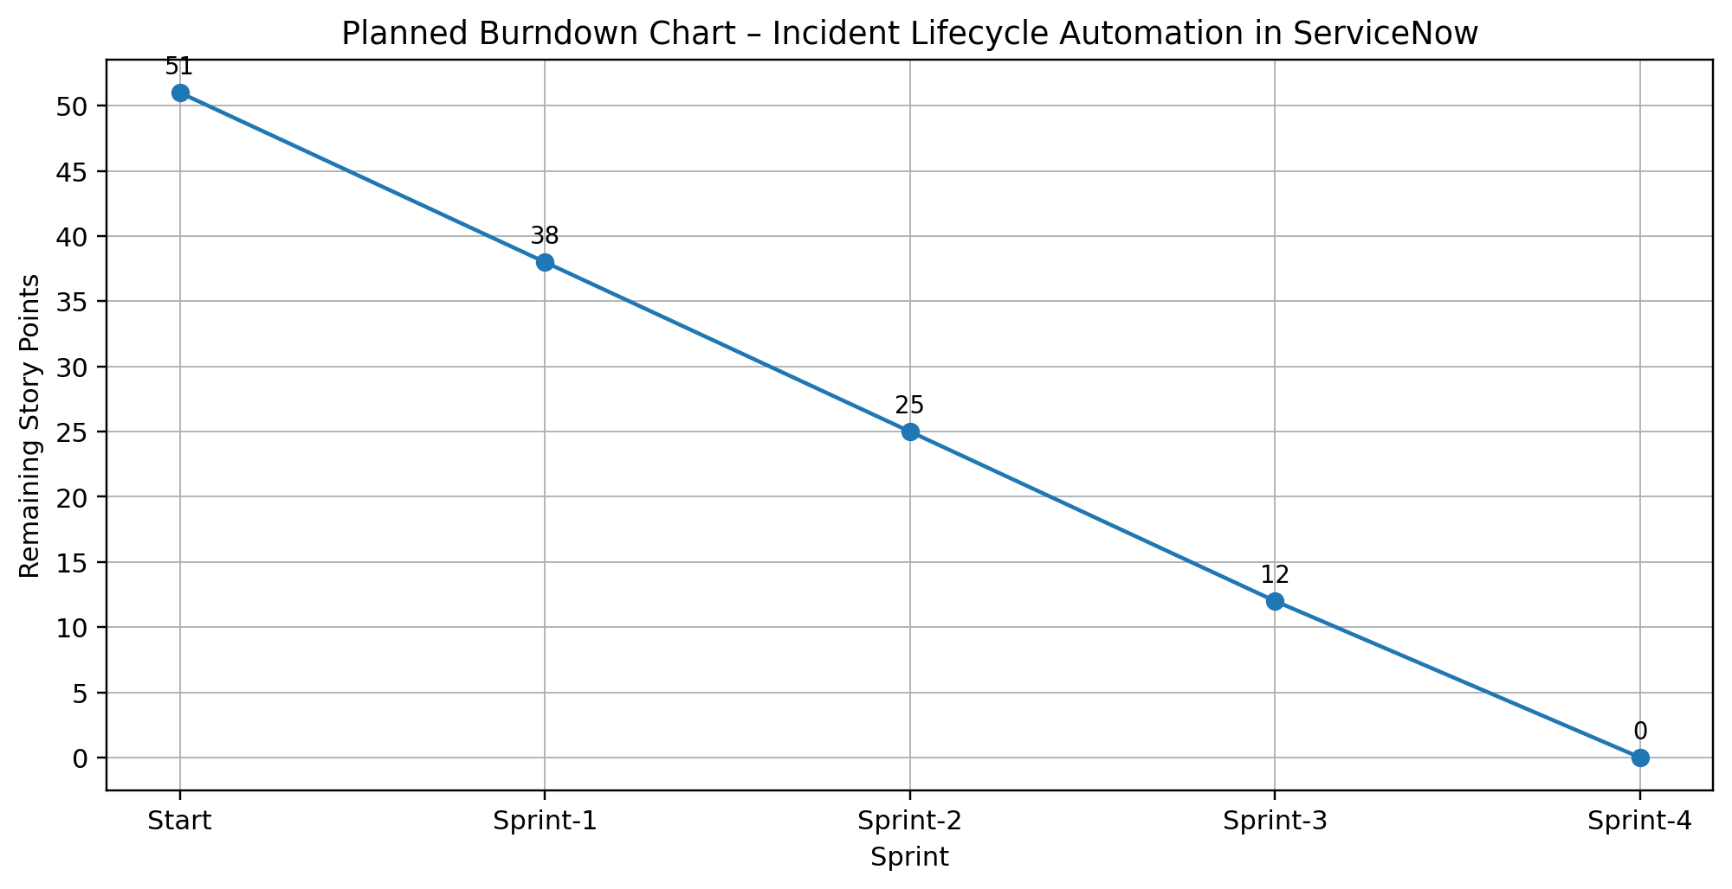

Burndown Chart: A burn down chart is a graphical representation of work left to do versus time. It is often used in agile software development methodologies such as Scrum and can be applied to projects containing measurable progress over time.
Planning Summary: 4 Sprints • 51 Total Story Points • 12.75 Story Points/Sprint

